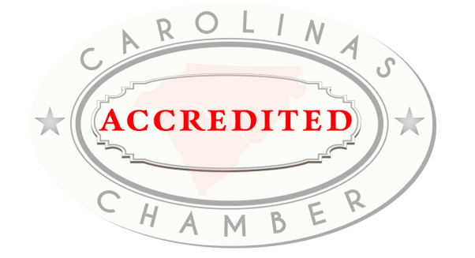
Carolinas Accredited Chambers
One of the most prestigious programs of CACCE is the Carolinas Accredited Chamber Program.
The program sets standards of excellence for chambers in the Carolinas, and it shows the chamber has gone through a detailed analysis of who and where they are as an organization.
We currently have 36 Carolinas Accredited Chambers:
Anderson Area (SC) Chamber Greater Cayce West Columbia (SC) Chamber
Asheville Area (NC) Chamber Greenwood (SC) Chamber
Beaufort Regional (SC) Chamber Haywood (NC) Chamber
Blowing Rock (NC) Chamber Hilton Head Island – Bluffton (SC) Chamber
Boone Area (NC) Chamber Lancaster County (SC) Chamber
Brunswick County (NC) Chamber Laurens County (SC) Chamber
Cabarrus Regional (NC) Chamber Laurinburg/Scotland County Area (NC) Chamber
Caldwell (NC) Chamber Little River (SC) Chamber
Charleston Metro (SC) Chamber Moore County (NC) Chamber
Columbia (SC) Chamber Myrtle Beach Area (SC) Chamber
Garner (NC) Chamber North Augusta (SC) Chamber
Gaston (NC) Business Association North Myrtle Beach Area (SC) Chamber
Georgetown County (SC) Chamber Outer Banks (NC) Chamber
Greater Fayetteville (NC) Chamber Richmond County (NC) Chamber
Greater Lexington (SC) Chamber Union County (SC) Chamber
Greater Smithfield-Selma Area (NC) Chamber Wilkes (NC) Chamber
Greater Summerville/Dorchester County (SC) Chamber Wilson (NC) Chamber
Greater Sumter (SC) Chamber York County Regional (SC) Chamber

